- Arban Conservatory Method “Characteristic Study 7” measures 25-55. Suggested tempo: quarter note = 80-92

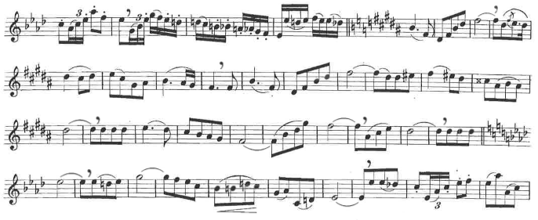

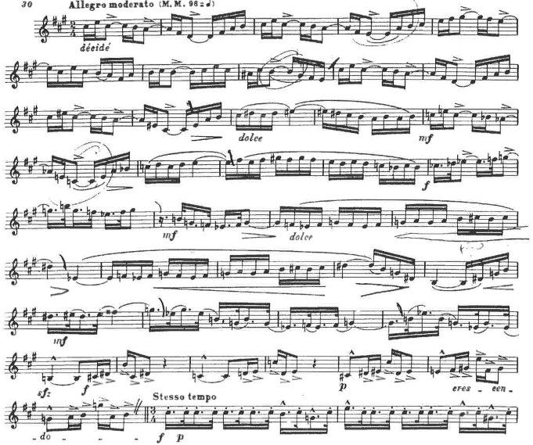
- Charlier “Etude 12” measures 1-40. Suggested tempo as indicated.

