- Bordogni Melodious Etudes for Trombone, “Etude 18” measures 51-end. Suggested tempo: quarter note = 120-132
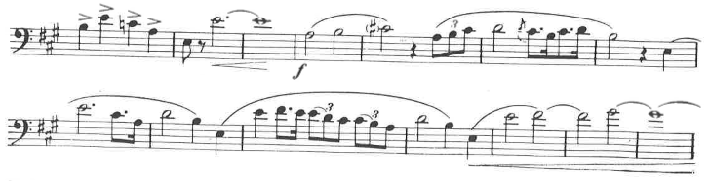

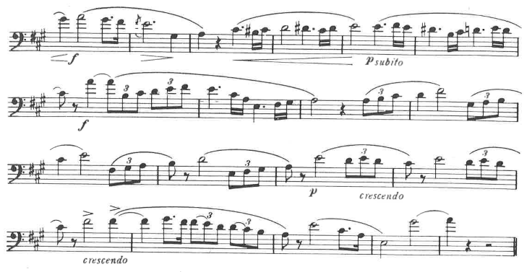

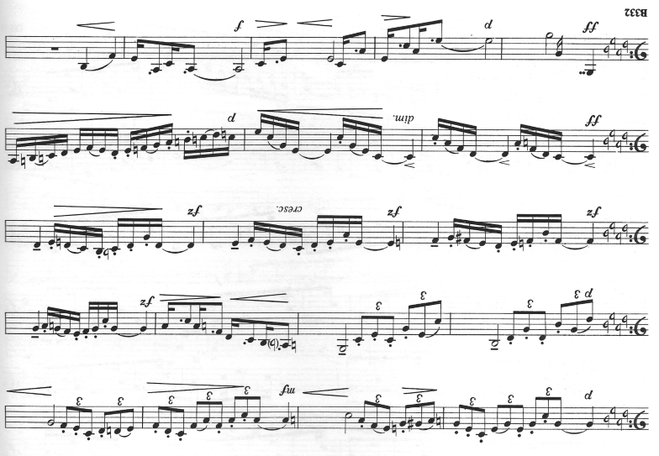
- Paudert 24 Studies for Trombone, “Etude 5”, measures 17-31. Suggested tempo: quarter = 92.

