- Ferling 48 Famous Studies for Saxophone, “Etude 12” all. Suggested tempo: quarter note = 132
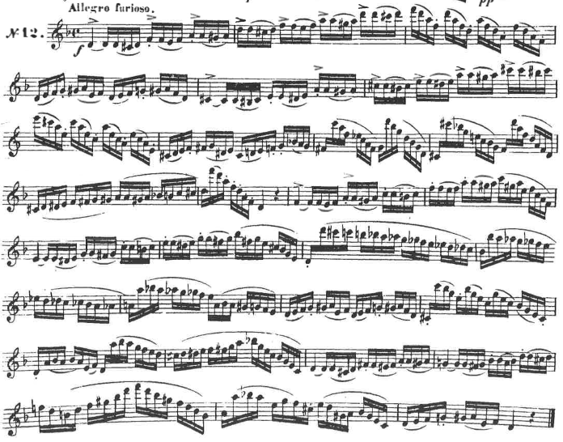

- Ferling 48 Famous Studies for Saxophone, “Etude 17” measures 1-8. Suggested tempo: eighth note = 88
