- Ferling 48 Famous Studies for Oboe, “Etude 5” measures 1-16. Suggested tempo: eighth note = 88
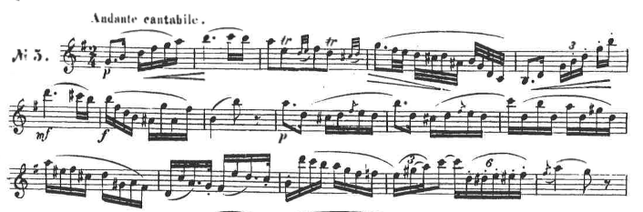

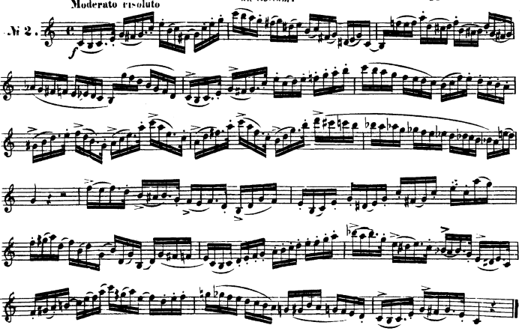
- Ferling 48 Famous Studies for Oboe, “Etude 2” all. Suggested tempo: quarter note = 86-104

