- Kopprasch 60 Selected Studies, “Etude 18” measure 1-24 beat 2. Suggested tempo: quarter note = 65-70. NO REPEATS!!

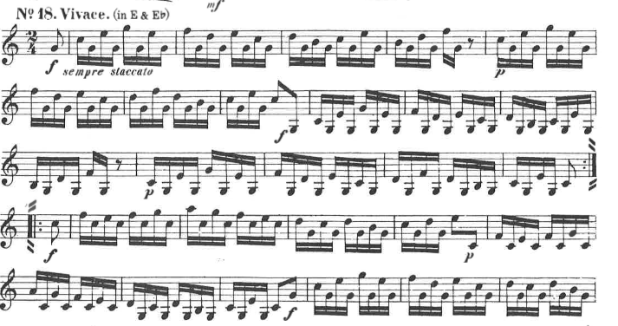

- Shoemaker Legato Etudes for French Horn, “Etude 15” measure 1-24. Suggested tempo: quarter note = 120
