- 24 Short Concert Pieces for Flute and Piano, “Hungarian Serenade” measures 49-65. Suggested tempo: eighth note = 72
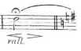
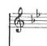

(continue on without pause)

- Karg-Elert 30 Caprices for Flute, “Etude 9” all. Suggested tempo: quarter note = 48 (sixteenth stays constant.)
