When you complete a challenge, take a screenshot and send it to Mrs. B.

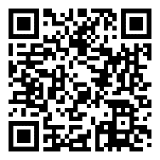
- Note Identification – Treble Clef: https://www.musictheory.net/exercises/note/brwyrybynyyyyy
  - Name the note!
  - Level 1 GOAL: 100 correct answers, at least 90% accuracy
  - Level 2 GOAL: 75 correct answers, 100% accuracy

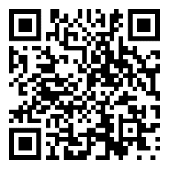
- Note Identification – Bass Clef: https://www.musictheory.net/exercises/note/nrwyrybynyyyyy
  - Name the note!
  - Level 1 GOAL: 100 correct answers, at least 90% accuracy
  - Level 2 GOAL: 75 correct answers, 100% accuracy

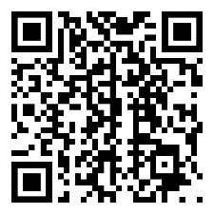
- Major Key Signatures – Treble Clef: https://www.musictheory.net/exercises/keysig/b999yydyyyyy
  - When you see this key signature, what note does that scale start on?
  - Level 1 GOAL: 50 correct answers, at least 80% accuracy
  - Level 2 GOAL: 50 correct answers, at least 90% accuracy

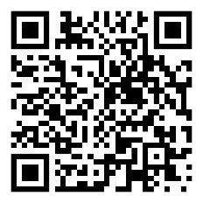
- Major Key Signatures – Bass Clef: https://www.musictheory.net/exercises/keysig/n999yydyyyyy
  - When you see this key signature, what note does that scale start on?
  - Level 1 GOAL: 50 correct answers, at least 80% accuracy
  - Level 2 GOAL: 50 correct answers, at least 90% accuracy

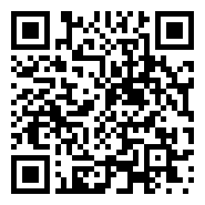
- Minor Key Signatures – Treble Clef: https://www.musictheory.net/exercises/keysig/b999bydyyyyy
  - When you see this key signature, what note does that scale start on?
  - Level 1 GOAL: 50 correct answers, at least 70% accuracy
  - Level 2 GOAL: 50 correct answers, at least 80% accuracy

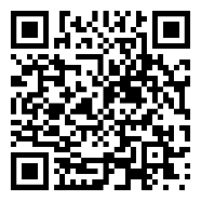
- Minor Key Signatures – Bass Clef: https://www.musictheory.net/exercises/keysig/n999bydyyyyy
  - When you see this key signature, what note does that scale start on?
  - Level 1 GOAL: 50 correct answers, at least 70% accuracy
  - Level 2 GOAL: 50 correct answers, at least 80% accuracy

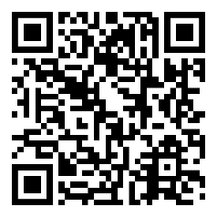
- Scale Identification – Treble Clef: https://www.musictheory.net/exercises/scale/brwxyyya99ynyyy
  - Is the scale shown major, natural, harmonic, or melodic minor?
  - Level 1 GOAL: 50 correct answers, at least 80% accuracy
  - Level 2 GOAL: 50 correct answers, at least 90% accuracy

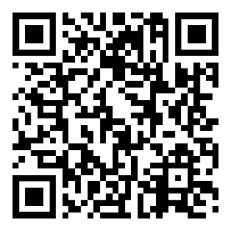
- Scale Identification – Bass Clef: https://www.musictheory.net/exercises/scale/nrwxyyya99ynyyy
  - Is the scale shown major, natural, harmonic, or melodic minor?
  - Level 1 GOAL: 50 correct answers, at least 80% accuracy
  - Level 2 GOAL: 50 correct answers, at least 90% accuracy

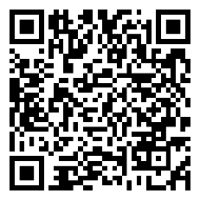
- Intervals By Ear:
https://www.musictheory.net/exercises/ear-interval/998byyngneyyyyyy
  - An interval will be played – identify it (example: major 3rd, perfect 5th)
  - Level 1 GOAL: 50 correct answers, at least 70% accuracy
  - Level 2 GOAL: 40 correct answers, at least 80% accuracy

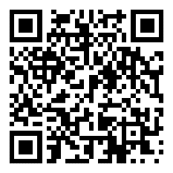
- Scales By Ear:
https://www.musictheory.net/exercises/ear-scale/xyybyyngneyyyy
  - What scale do you hear? (major, natural, harmonic, or melodic minor)
  - Level 1 GOAL: 50 correct answers, at least 80% accuracy
  - Level 2 GOAL: 40 correct answers, at least 90% accuracy

