- Milde 50 Concert Studies for Bassoon, “Etude 30” measures 1-16. Suggested tempo: quarter note = 60
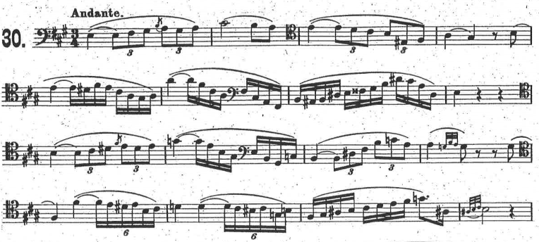

- Milde 50 Concert Studies for Bassoon, “Etude 31” measures 1-16. Suggested tempo: dotted quarter note = 76
