- Rose 40 Studies, “Etude 24” measures 22-end. Suggested tempo: quarter note = 72
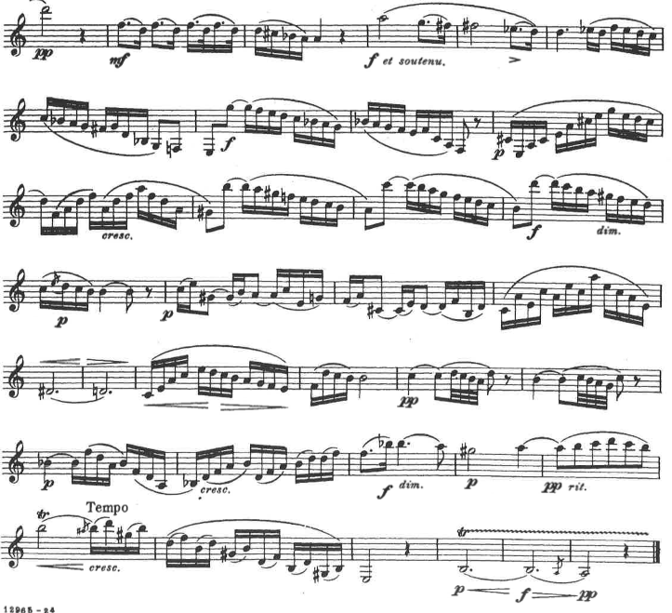

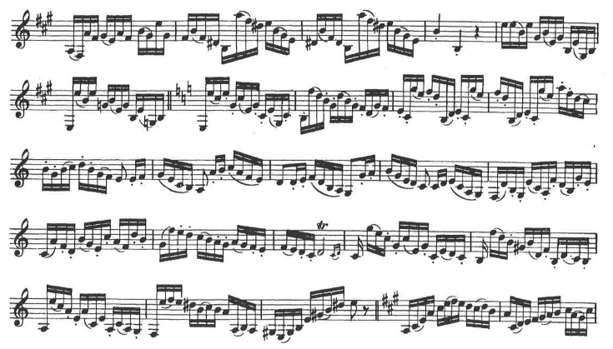
- Rose 40 Studies, “Etude 31” measures 19-37. Suggested tempo: quarter note = 100

