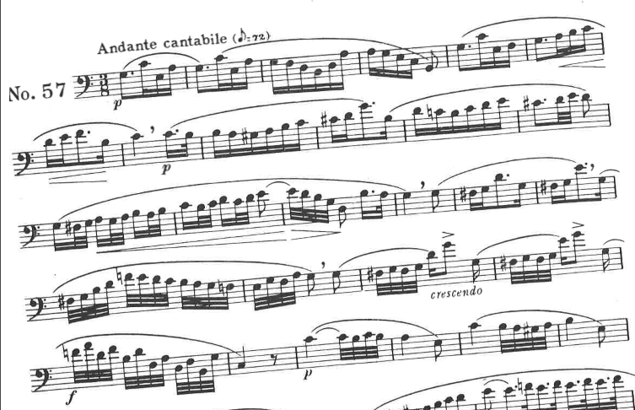
- Bordogni Melodious Etudes for Trombone, “Etude 57” measures 1-24. Suggested tempo: eighth note = 72

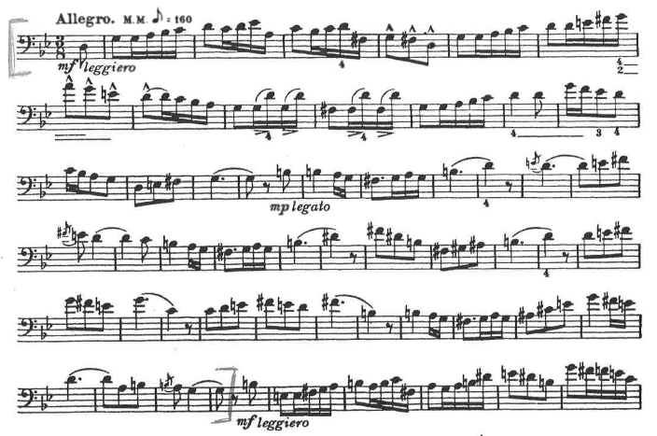
- Tyrell – 40 Progressive Studies for Trombone, “Etude 11”, measures 1-48. Suggested tempo: eighth note = 160

