- Ferling 48 Famous Studies for Saxophone, “Etude 40” measures 1-40. Suggested tempo: dotted quarter note = 72
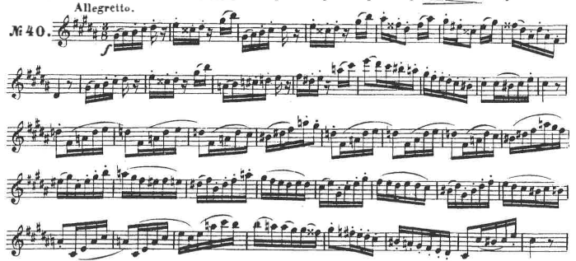

- Ferling 48 Famous Studies for Saxophone, “Etude 27” measures 1-16. Suggested tempo: eighth note = 96
