SCALES (see attached scale sheet)
- W. Ferling – 48 Famous Studies for Saxophone, #11 measures 15-end
Suggested Tempo: eighth note = 72
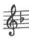
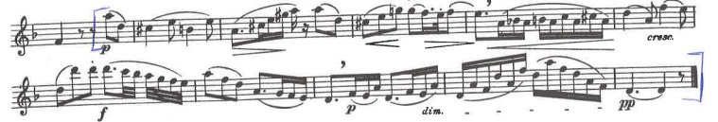

- W. Ferling – 48 Famous Studies for Saxophone, #20 all
Suggested Tempo: quarter note = 112
