SCALES (see attached scale sheet)
- W. Ferling – 48 Studies for Oboe, #7, beginning to second breath mark in the third line
Suggested Tempo: 60 bpm
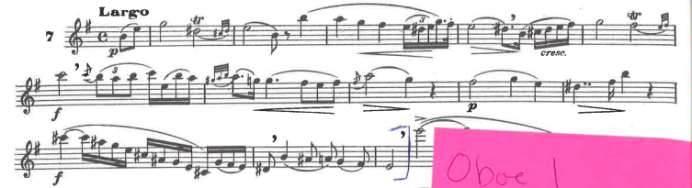

- W. Ferling – 48 Studies for Oboe, #24, beginning to “a tempo”
Suggested Tempo: dotted quarter note = 63-70
