SCALES (see attached scale sheet)
- C. Rose – 40 Studies for Clarinet, #13 measures 25-44
Suggested Tempo: quarter note = 66-72
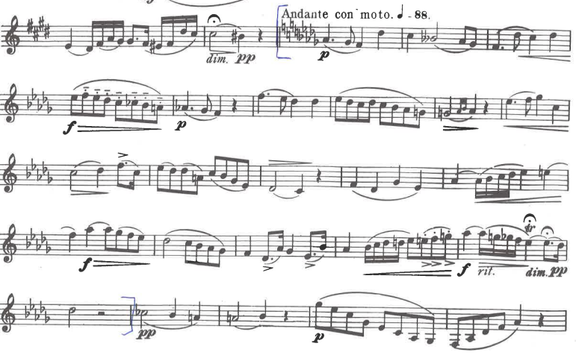

(other excerpt on the back)

- C. Rose – 32 Etudes for Clarinet, #26, measures 1-20, no repeat.
Suggested Tempo: quarter note = 120 or faster
