SCALES (see attached scale sheet)
- J. Weissenborn – Bassoon Studies for Advanced Players, Pg. 17 #21, measures 13-27
Suggested Tempo: quarter note = 76

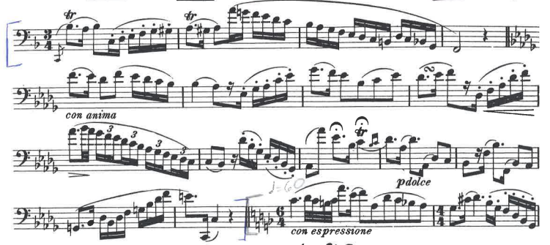

- J. Weissenborn – Bassoon Studies for Advanced Players, Pg. 35 # 42, measure 40 to the end
Suggested Tempo: quarter note = 116
