SCALES (see attached scale sheet)
- C. Rose – 32 Etudes for Clarinet, #31 measures 15-30
Suggested Tempo: quarter note = 58
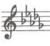
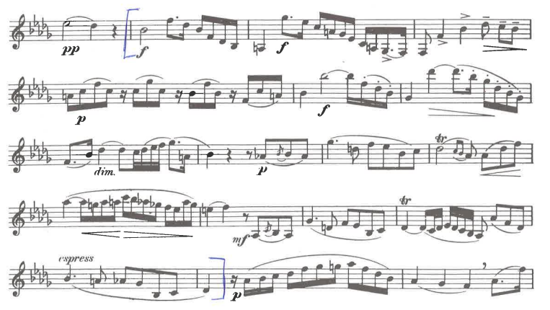
- C. Rose – 40 Studies for Clarinet, #37, measures 1-16
Suggested Tempo: quarter note = 100 or faster
