SCALES (see attached scale sheet)
- Voxman Selected Studies – pg. 16, measures 1-8
Suggested Tempo: eighth note = 66
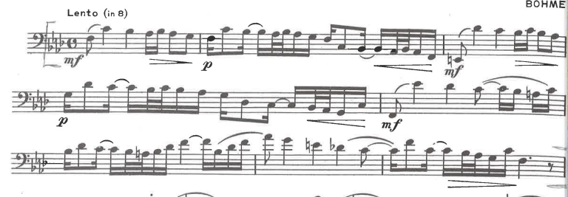
- Tyrell – 40 Progressive Studies, #23, measures 1-32
Suggested Tempo: quarter note = 80
