SCALES (see attached scale sheet)
- Bordogni/Roberts – 43 Bel Canto Studies for Bass Trombone and Tuba, #21, measures 1-16 (beat 3)
Suggested Tempo: quarter note = 88
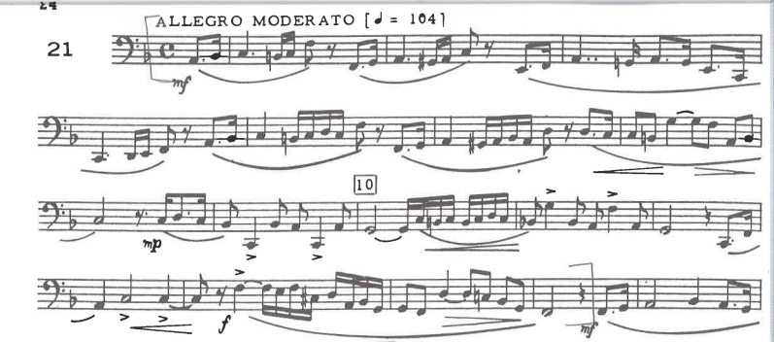
- Tyrell – 40 Advanced Studies for Bb Bass, #22, measures 1-25 (beat 1)
Suggested Tempo: quarter note = 100
