SCALES (see attached scale sheet)
- J. L. Small – 27 Melodious and Rhythmical Exercises for Trumpet, #25, beginning to beat one of measure 37
Suggested Tempo: 66 or faster
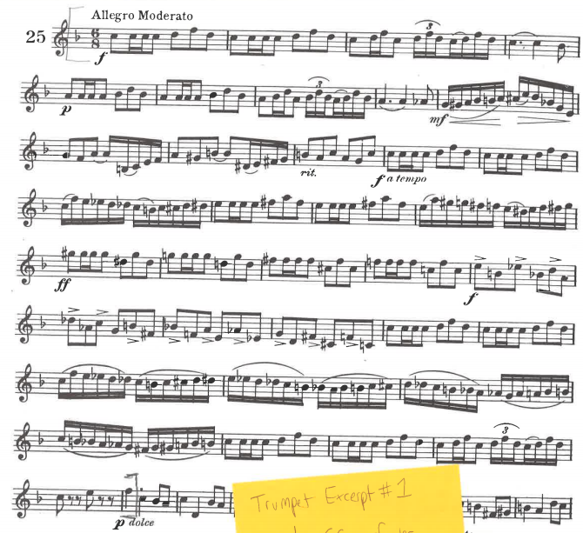

- Charlier Etudes Transcendantes, pg. 16 #8, beginning to end of measure 16
Suggested Tempo: eighth note = 138
