SCALES (see attached scale sheet)
- Kopprasch – 60 Selected Studies for French Horn, #27, measures 1-first ending
Suggested Tempo: quarter note = 76-90
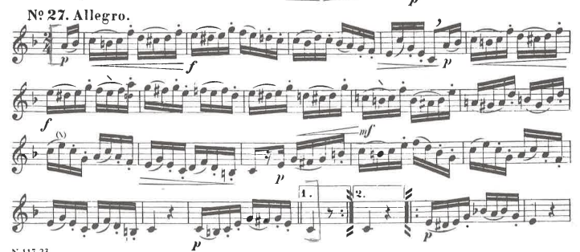
- John R. Shoemaker – Legato Etudes for French Horn, #6, beginning to first note of measure 30
Suggested Tempo: quarter note = 104
