SCALES (see attached scale sheet)
- 24 Short Concert Pieces for Flute, Melodie-elegie by Massenet, measures 5-20.
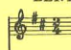
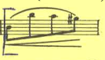
Suggested Tempo: eighth note = 60

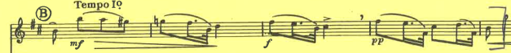
- Karg-Elert 30 Caprices for Flute, #19 all
Suggested Tempo: quarter note = 100

