SCALES (see attached scale sheet)
- W. Ferling – 48 Famous Studies for Saxophone, #9 measures 1-16
Suggested Tempo: eighth note = 72
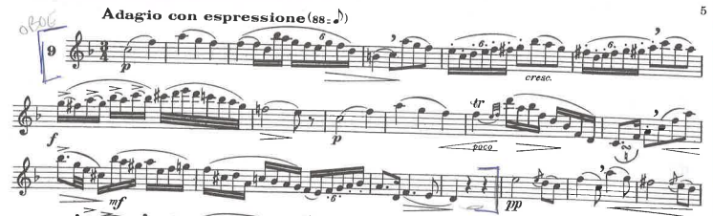

- W. Ferling – 48 Famous Studies for Saxophone, #26 all
Suggested Tempo: quarter note = 112
